 CENTRAL BOARD OF SECONDARY EDUCATION

JAWAHAR NAVODAYA VIDYALAYA
TARIKHET ALMORA UTTARAKHAND 263663
COMPUTER SCIENCE (083)
PROJECT FILE
On
SCHOOL RESULT ANALYSER USING CSV FILE AND MODULES
SESSION: 2026-27
SUBMITTED BY :
S. No | Name | CBSE Roll
1.
2.
3.
4.

CLASS : XII
SECTION : SCIENCE

INTERNAL EXAMINER  (PANKAJ BHILINGWAL) |  | EXTERNAL EXAMINER |  | PRINCIPAL  (PANKAJ KUMAR SRIVASTAVA)

ACKNOWLEDGEMENT
I wish to express my deep sense of gratitude and indebtedness to our learned teacher Pankaj Bhilingwal, PGT Computer Science, J.N.V Tarikhet Almora for his invaluable help, advice and guidance in the preparation of this project file.
I am also greatly indebted to our principal Pankaj Kumar Srivastava and school authorities for providing me with the facilities and requisite laboratory conditions for making this project file.
I also extend my thanks to a number of teachers, my classmates and friends who helped me to complete this project file successfully.

Signature of Student

CERTIFICATE
This is to certify that,
S. No | Name | CBSE Roll

Student of Class XII, J.N.V Tarikhet Almora has completed the PROJECT FILE titled “School Result Analyser Using CSV File and Modules” during the academic year 2026-27 towards partial fulfilment of credit for the Computer Science Project evaluation of CBSE and submitted satisfactory report, as compiled in the following pages, under my supervision.
Internal Examiner | External Examiner
Signature | Signature

PREFACE
In the field of Computer Science, the term PROJECT refers to a computerization work that is completely performed by using a computer. Today almost every field is computerized, and the different tasks of every field are done using computers and appropriate computer programs. Such programs and software are developed in the form of Projects.
Learning Python in schools is a part of our syllabus, and according to the syllabus worked out by the CBSE, to which my school is affiliated, I enjoyed doing project work for the session 2026-27. I learned a lot, especially learning by doing was a great experience. The report is a summary of what I observed and learnt in school. My humble thanks go to all those concerned with my project.
I also feel that it is the right time to thank my teacher, who guided me during my project, and my parents, friends and project partners for the constant assistance and cooperation extended by them from time to time.

INDEX
S. No | Topic | Page No
1 | About Project | 6
2 | Syllabus Concepts Used | 8
3 | Flow Chart | 9
4 | Project Code | 10
5 | Output | 15
6 | Technological Requirements: Hardware & Software | 20
7 | References | 20

About Project

School Result Analyser Using CSV File and Modules
The School Result Analyser is a menu-driven Python program that reads the marks of Class XII students from a CSV file and prepares their result. It calculates total, percentage, grade and pass/fail status, finds subject-wise toppers, analyses the performance of the whole class and generates a report card for every student as a separate text file.
Unlike a single-file program, this project is divided into three files: main.py (menu), fileops.py (file work) and analysis.py (calculations). fileops and analysis are our own user-defined modules which are imported in main.py. This makes the program easier to read, test and reuse.

Project Overview
Objective:
The objective of this project is to learn how to create and use user-defined modules, and how to work with two types of files - CSV and text files - in one project. It also saves the time of a class teacher who has to calculate the result of many students.
Key Features:
- Display Result: Shows marks, total, percentage, grade and result of all students in a table.
- Add Student Marks: Adds a new student's marks to marks.csv after checking that marks are between 0 and 100.
- Search Student: Shows the complete result of one student by roll number.
- Subject-wise Toppers: Finds the highest scorer in every subject.
- Class Analysis: Shows pass/fail count, pass percentage, class average, class topper and grade distribution.
- Generate Report Cards: Creates a text file report card for every student in the reports folder.
- View Report Card: Reads a report card text file and displays it.

Technology Stack
Programming Language: Python 3
Modules Used: csv, os, and user-defined modules fileops and analysis
fileops.py uses the csv module (csv.reader, csv.writer) to read and append marks, and text file functions (writelines, readline, read, tell, seek) for report cards. analysis.py contains only calculation functions with default arguments and multiple return values. main.py imports both modules and contains the menu. Grades follow the CBSE pattern (A1, A2, B1, B2, C1, C2, D, E) and a student must score at least 33 in every subject to pass.

Files in this Project
File | Purpose
main.py | Main program with menu - run this file
fileops.py | User-defined module for CSV and text file operations
analysis.py | User-defined module for calculations
marks.csv | CSV file with roll number, name and marks of 5 subjects
reports/ | Folder of report card text files (created by option 6)
flowchart.py / flowchart.png | Flowchart program and image
img/ | Screenshots of the output

How to Run the Program
- Make sure Python 3 is installed on the computer.
- Keep main.py, fileops.py, analysis.py and marks.csv in the SAME folder.
- Open main.py in IDLE and press F5 (or run: python main.py).
- marks.csv can also be opened and edited in MS-Excel.

Syllabus Concepts Used
This project covers the following topics of the CBSE Class XII Computer Science (083) syllabus:
Concept | Where it is used in the project
User-defined modules | fileops.py and analysis.py imported with import and from ... import
CSV file handling | csv.reader() with next() to skip heading, csv.writer() with writerow()
Text file handling | writelines(), readline(), read(), tell() and seek() in fileops.py
Default arguments | percentage(total, subjects=5, max_marks=100), result(marks, pass_marks=33)
Returning multiple values | student_summary() returns total, percentage, grade and result as a tuple
Exception handling | try-except ValueError while entering marks
Lists and dictionaries | Student records as lists; grade counts in a dictionary
os module | os.path.exists() and os.mkdir() to create the reports folder

What is a module?
A module is a Python file (.py) containing functions and variables that can be used in other programs with the import statement. Python has built-in modules like csv, os and math, and we can also create our own modules.
Dividing a big program into modules keeps related functions together. In this project, all file related functions are in fileops.py and all calculations are in analysis.py, so the main program stays short and simple.

Flow Chart

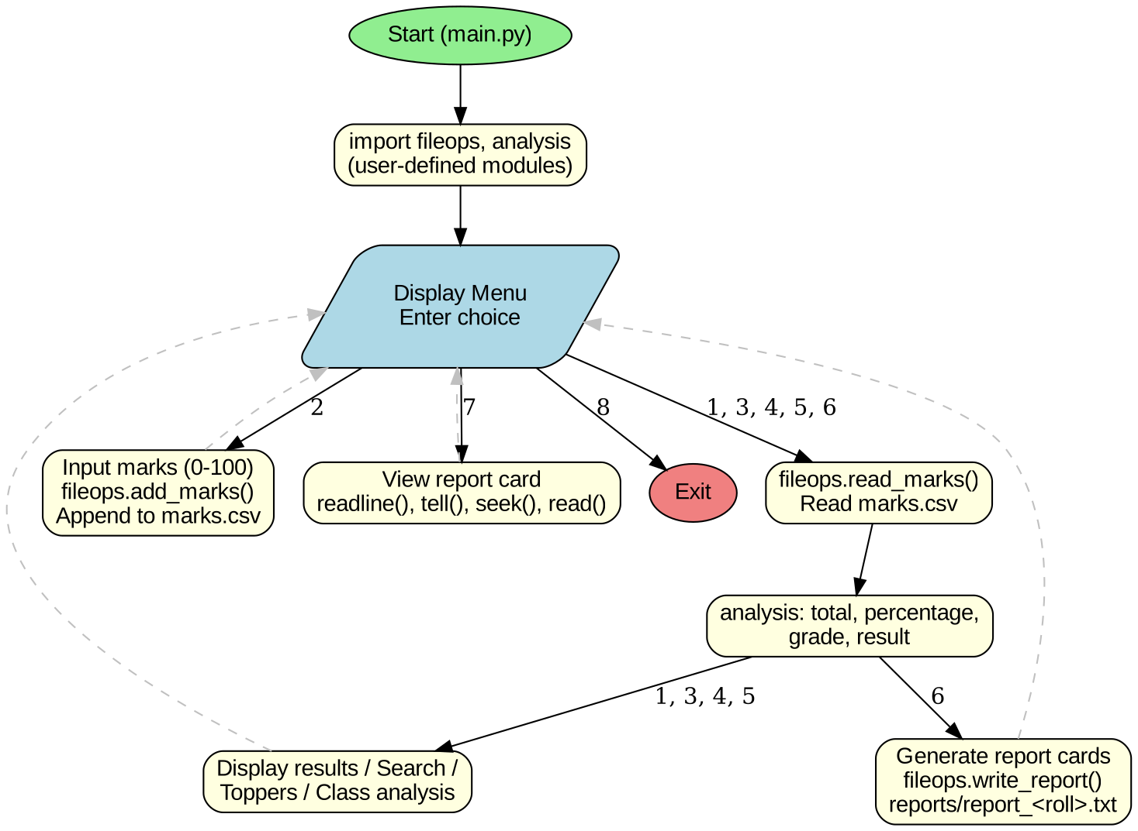

Project Code

main.py
# main.py
# School Result Analyser - menu driven program
# Run this file. It uses our own modules fileops.py and analysis.py
import fileops
import analysis
from fileops import SUBJECTS
def get_marks(subject):
while True:
try:
m = int(input("Enter marks in " + subject + " (0-100): "))
if 0 <= m <= 100:
return m
print("Marks must be between 0 and 100.")
except ValueError:
print("Please enter a number.")
def display_all():
students = fileops.read_marks()
if len(students) == 0:
print("No records found.")
return
print("%-5s %-16s %5s %5s %5s %5s %5s %6s %7s %5s %6s" %
("Roll", "Name", "Eng", "Phy", "Chem", "Math", "CS", "Total", "Per%", "Grade", "Result"))
print("-" * 82)
for s in students:
t, p, g, r = analysis.student_summary(s)
print("%-5s %-16s %5d %5d %5d %5d %5d %6d %7.2f %5s %6s" %
(s[0], s[1], s[2], s[3], s[4], s[5], s[6], t, p, g, r))
def add_student():
students = fileops.read_marks()
roll = input("Enter Roll Number: ")
for s in students:
if s[0] == roll:
print("Roll number already exists!")
return
name = input("Enter Student Name: ")
row = [roll, name]
for sub in SUBJECTS:
row.append(get_marks(sub))
fileops.add_marks(row)
print("Marks of", name, "saved successfully.")
def search_student():
roll = input("Enter Roll Number to search: ")
for s in fileops.read_marks():
if s[0] == roll:
t, p, g, r = analysis.student_summary(s)
print("Name:", s[1])
for i in range(len(SUBJECTS)):
print(" ", SUBJECTS[i], ":", s[i + 2])
print("Total:", t, "| Percentage:", p, "| Grade:", g, "| Result:", r)
return
print("No student with roll number", roll)
def subject_toppers():
students = fileops.read_marks()
if len(students) == 0:
print("No records found.")
return
print("Subject-wise Toppers")
print("--------------------")
for i in range(len(SUBJECTS)):
name, marks = analysis.subject_topper(students, i + 2)
print("%-10s : %-16s (%d)" % (SUBJECTS[i], name, marks))
def class_analysis():
students = fileops.read_marks()
if len(students) == 0:
print("No records found.")
return
passed = 0
grades = {}
topper = ""
top_per = -1
for s in students:
t, p, g, r = analysis.student_summary(s)
if r == "PASS":
passed = passed + 1
grades[g] = grades.get(g, 0) + 1
if p > top_per:
top_per = p
topper = s[1]
print("Total Students :", len(students))
print("Passed :", passed)
print("Failed :", len(students) - passed)
print("Pass Percentage:", round(passed * 100 / len(students), 2), "%")
print("Class Average :", analysis.class_average(students), "%")
print("Class Topper :", topper, "(", top_per, "% )")
print("Grade Distribution:")
for g in ["A1", "A2", "B1", "B2", "C1", "C2", "D", "E"]:
if g in grades:
print(" ", g, ":", "*" * grades[g], grades[g])
def generate_reports():
students = fileops.read_marks()
count = 0
for s in students:
t, p, g, r = analysis.student_summary(s)
lines = []
lines.append("REPORT CARD - CLASS XII\n")
lines.append("Roll No : " + s[0] + "\n")
lines.append("Name : " + s[1] + "\n")
lines.append("-" * 28 + "\n")
for i in range(len(SUBJECTS)):
lines.append("%-12s %5d\n" % (SUBJECTS[i], s[i + 2]))
lines.append("-" * 28 + "\n")
lines.append("Total : " + str(t) + " / 500\n")
lines.append("Percentage : " + str(p) + " %\n")
lines.append("Grade : " + g + "\n")
lines.append("Result : " + r + "\n")
fileops.write_report(s[0], lines)
count = count + 1
print(count, "report cards created in the folder '" + fileops.REPORT_FOLDER + "'")
def view_report():
roll = input("Enter Roll Number: ")
content, position = fileops.read_report(roll)
if content is None:
print("Report not found. Generate report cards first (option 6).")
return
print("(File pointer after reading first line was at byte", position, ")")
print(content)
def main():
while True:
print("\n====== SCHOOL RESULT ANALYSER ======")
print("1. Display Result of All Students")
print("2. Add Student Marks")
print("3. Search Student")
print("4. Subject-wise Toppers")
print("5. Class Analysis")
print("6. Generate Report Cards (text files)")
print("7. View a Report Card")
print("8. Exit")
choice = input("Enter your choice: ")
if choice == "1":
display_all()
elif choice == "2":
add_student()
elif choice == "3":
search_student()
elif choice == "4":
subject_toppers()
elif choice == "5":
class_analysis()
elif choice == "6":
generate_reports()
elif choice == "7":
view_report()
elif choice == "8":
print("Goodbye!")
break
else:
print("Invalid choice! Please try again.")
main()

fileops.py
# fileops.py
# User-defined module: all FILE related work (CSV file and text files)
import csv
import os
MARKS_FILE = "marks.csv"
REPORT_FOLDER = "reports"
SUBJECTS = ["English", "Physics", "Chemistry", "Maths", "CS"]
def read_marks():
# Returns a list of students. Each student is a list:
# [roll, name, m1, m2, m3, m4, m5] (marks are converted to int)
students = []
if not os.path.exists(MARKS_FILE):
return students
f = open(MARKS_FILE, "r", newline="")
reader = csv.reader(f)
next(reader) # skip the heading row
for row in reader:
student = [row[0], row[1]]
for m in row[2:]:
student.append(int(m))
students.append(student)
f.close()
return students
def add_marks(row):
# Append one student row to the CSV file
new_file = not os.path.exists(MARKS_FILE)
f = open(MARKS_FILE, "a", newline="")
writer = csv.writer(f)
if new_file:
writer.writerow(["RollNo", "Name"] + SUBJECTS)
writer.writerow(row)
f.close()
def write_report(roll, lines):
# Write a report card (list of lines) into a text file
if not os.path.exists(REPORT_FOLDER):
os.mkdir(REPORT_FOLDER)
file_name = REPORT_FOLDER + "/report_" + roll + ".txt"
f = open(file_name, "w")
f.writelines(lines)
f.close()
return file_name
def read_report(roll):
# Read a report card text file and show tell() / seek() use
file_name = REPORT_FOLDER + "/report_" + roll + ".txt"
if not os.path.exists(file_name):
return None, 0
f = open(file_name, "r")
first_line = f.readline() # read only the first line
position = f.tell() # where the file pointer is now
f.seek(0) # go back to the beginning
content = f.read() # read the whole file
f.close()
return content, position

analysis.py
# analysis.py
# User-defined module: all CALCULATIONS on marks
def total(marks):
t = 0
for m in marks:
t = t + m
return t
def percentage(total_marks, subjects=5, max_marks=100):
# Default arguments: 5 subjects of 100 marks each
return round(total_marks * 100 / (subjects * max_marks), 2)
def grade(per):
# CBSE style grades
if per >= 91:
return "A1"
elif per >= 81:
return "A2"
elif per >= 71:
return "B1"
elif per >= 61:
return "B2"
elif per >= 51:
return "C1"
elif per >= 41:
return "C2"
elif per >= 33:
return "D"
else:
return "E"
def result(marks, pass_marks=33):
# A student passes only if every subject has at least 33 marks
for m in marks:
if m < pass_marks:
return "FAIL"
return "PASS"
def student_summary(student):
# Returns MORE THAN ONE value (a tuple)
marks = student[2:]
t = total(marks)
p = percentage(t)
return t, p, grade(p), result(marks)
def subject_topper(students, index):
# index = position of the subject in the student list (2 to 6)
best = students[0]
for s in students:
if s[index] > best[index]:
best = s
return best[1], best[index]
def class_average(students):
if len(students) == 0:
return 0
sum_per = 0
for s in students:
t, p, g, r = student_summary(s)
sum_per = sum_per + p
return round(sum_per / len(students), 2)

Output

Output 1: Result of All Students
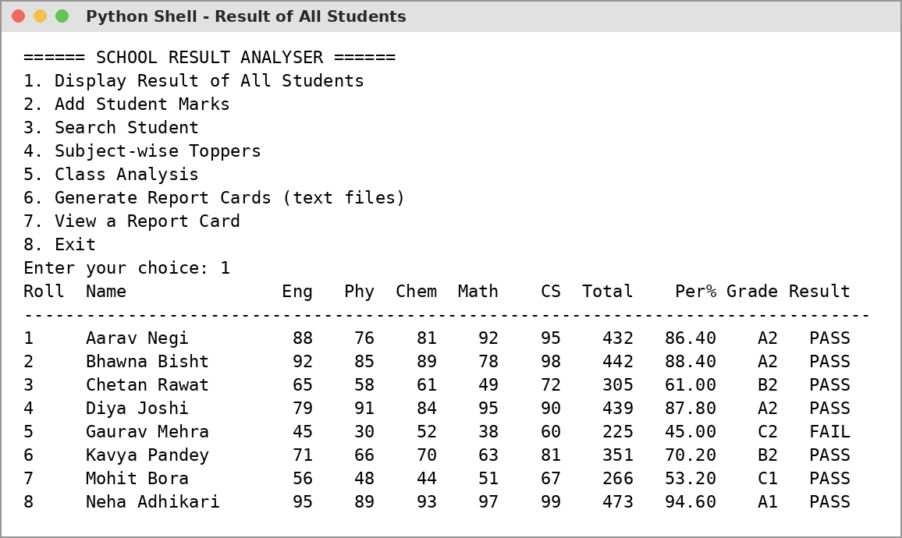

Output 2: Adding Student Marks
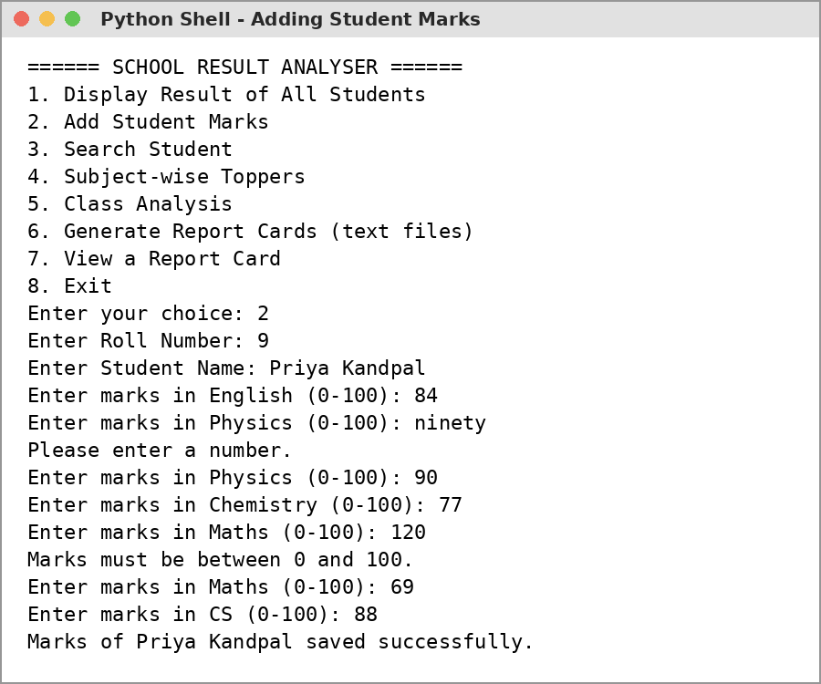

Output 3: Search and Subject Toppers
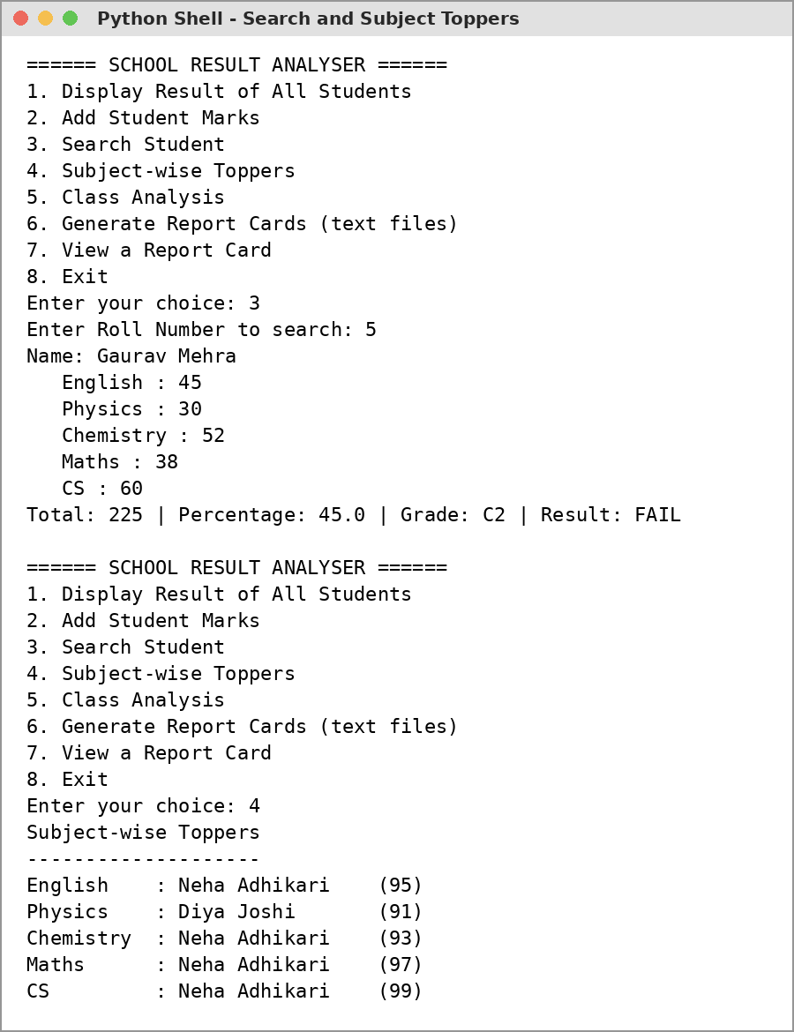

Output 4: Class Analysis
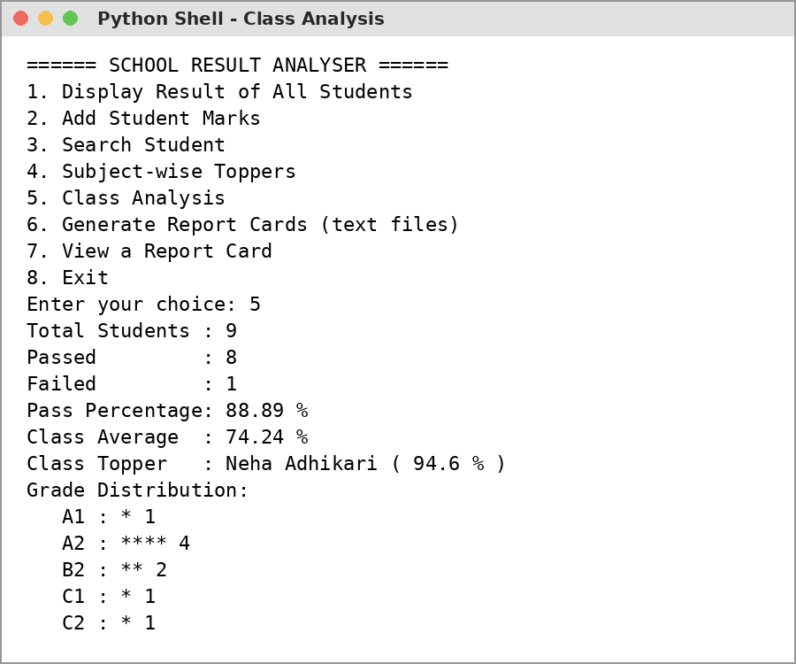

Output 5: Report Cards (Text Files)
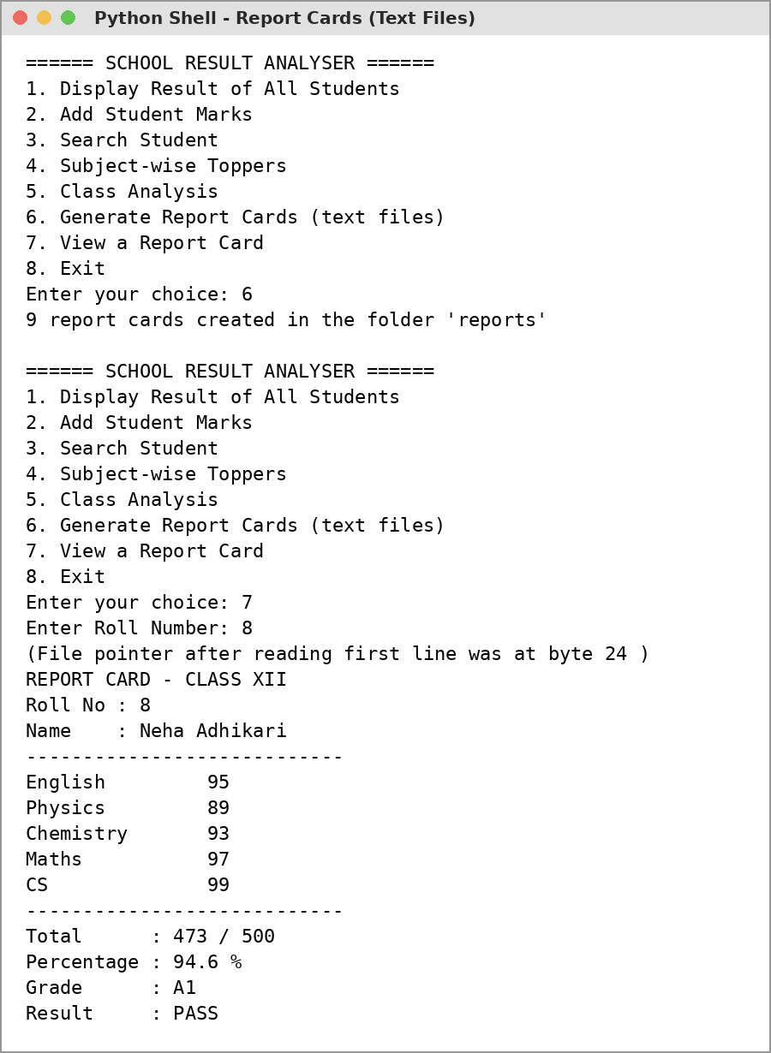

Output 6: Exit
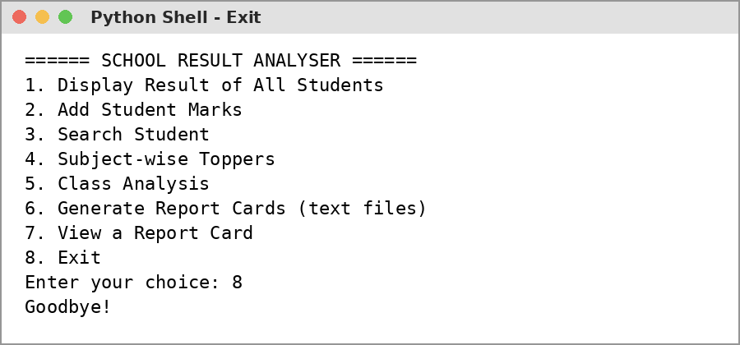

marks.csv (data file)
RollNo,Name,English,Physics,Chemistry,Maths,CS
1,Aarav Negi,88,76,81,92,95
2,Bhawna Bisht,92,85,89,78,98
3,Chetan Rawat,65,58,61,49,72
4,Diya Joshi,79,91,84,95,90
5,Gaurav Mehra,45,30,52,38,60
6,Kavya Pandey,71,66,70,63,81
7,Mohit Bora,56,48,44,51,67
8,Neha Adhikari,95,89,93,97,99
9,Priya Kandpal,84,90,77,69,88

Technological Requirements: Hardware & Software
Software
- Python 3.x (IDLE)
- VS Code / any text editor
- Microsoft Excel (to view marks.csv)
Hardware
- Laptop / PC with Intel Core i3 or above
- 4 GB RAM or more
- Keyboard and Mouse

References
- Computer Science with Python - Textbook for Class XII (Sumita Arora)
- NCERT Computer Science Textbook for Class XII, Chapters: Functions, File Handling
- https://docs.python.org/3/library/csv.html
- https://docs.python.org/3/tutorial/modules.html
- https://www.programiz.com/python-programming/csv

